**New York University Tandon School of Engineering**

Biomedical Engineering

Applied Mathematics and Statistics for Biomedical Engineering

Fall 2021

Professor Mirella Altoe

Tuesday 5:00-7:30PM Rogers Hall 325

# Computer Lab Assignment #7

**QUESTION 1:** *Spinocerebellar ataxia* type 1 is a neurodegenerative disease marked by the gradual loss of motor skills and culminating in early death. It is caused by an expanded CAG repeat in the coding region of the *Ataxin-1* gene. Fryer et al. (2011) investigated the possible beneficial effects of exercise in treating the disease. They used a mild exercise regimen in a mouse model of the disease (a mouse strain in which an expanded CAG repeat was “knocked in” to the mouse version of the same gene, and that had similar symptoms). The life spans (in days) are given below for six exercised mice and six mice not given the exercise regimen. The data and 95% confidence intervals are shown in the accompanying graph.

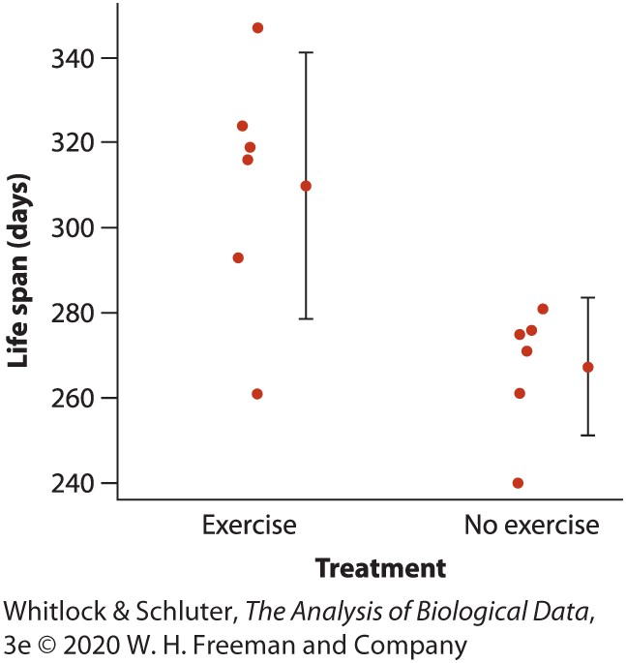No exercise: 240 , 261 , 271 , 275 , 276 , 281

Exercise: 261 , 293 , 316 , 319 , 324 , 247

1. **(0.50 pts.) What type of graph is shown?**  
   Interval plot
2. **(0.50 pts.)** **Using only the graph, is it possible to predict the outcome of a formal test of whether mean life span differs between the two treatments? Explain.**

No, we are unable to predict the outcome of the formal test just by looking at the graph. While the confidence intervals overlap one another, the means do not.

1. **(1.0 pt.) Test whether exercise affects life span in mice affected by the disease.**

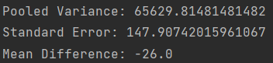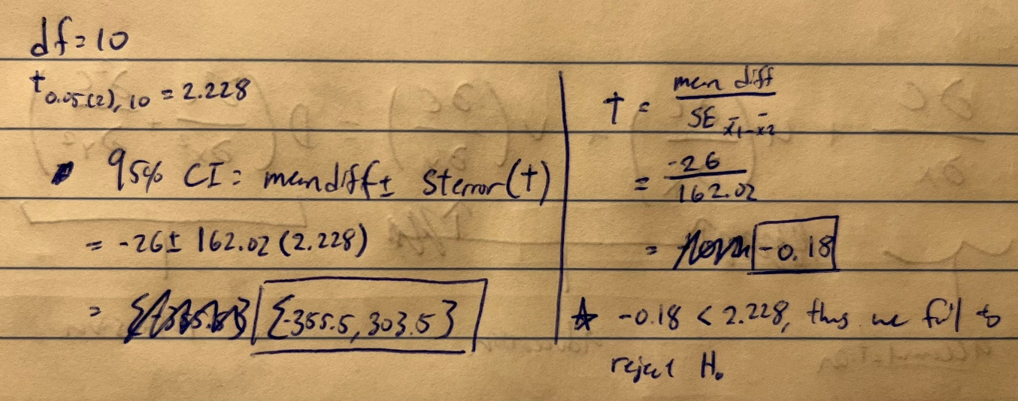

**QUESTION 2:** Females of many animals can recognize their own offspring by voice. But how long does this vocal memory last? Briefer et al. (2012) tested the responses of mother goats to their offspring 11 to 17 months after the kids were independent of their mothers. They scored the behavioral response of each of nine mothers (based on how fast her response was, how often the offspring called in return, and how long the mother looked at the loudspeaker) when played a recording of one of her former kids. The researchers also scored her behavioral response to recordings of unrelated kids of the same age. The scores are below.

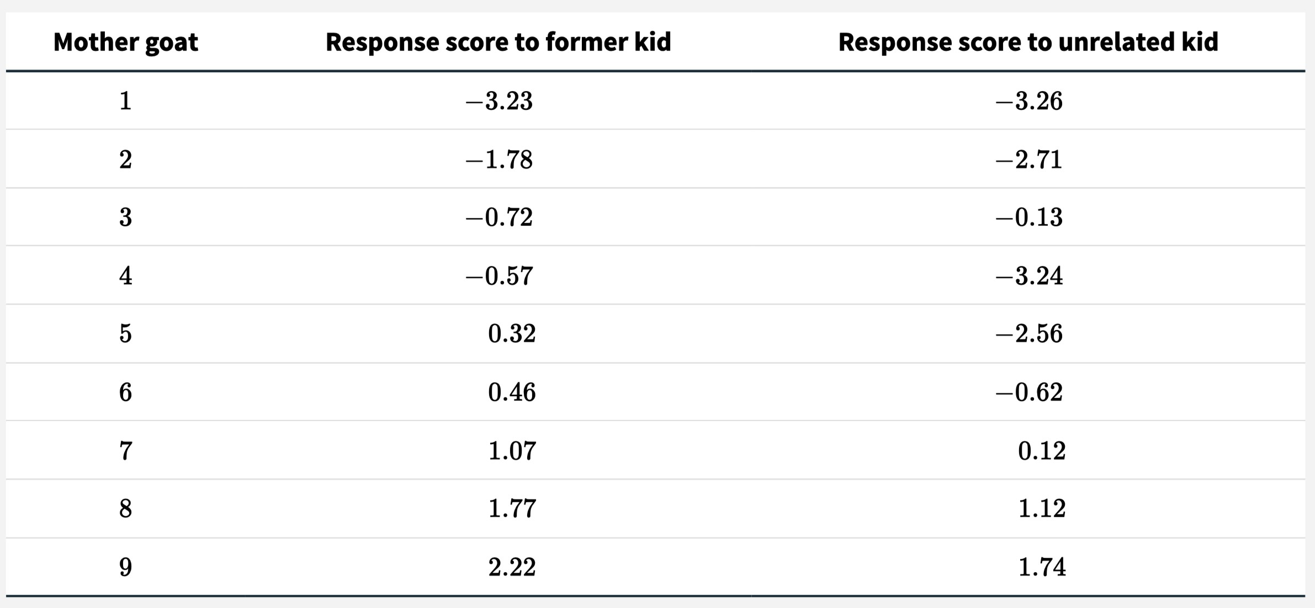

1. **(1.0 pt.)** Test the null hypothesis that there is no difference between the response scores of mothers to former kids compared to unrelated kids.



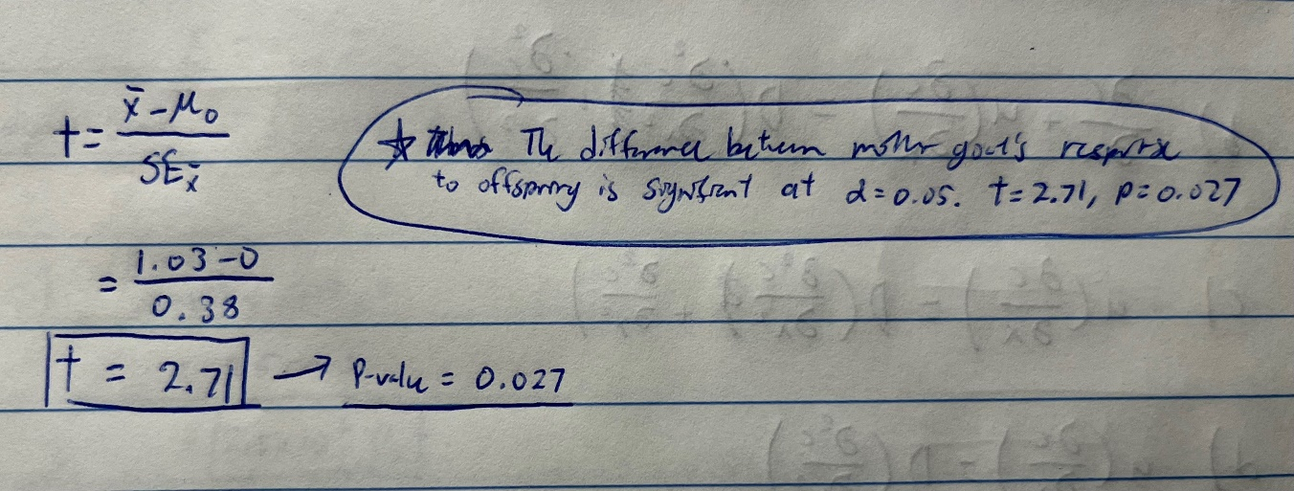

**QUESTION 3:** For each of the following scenarios, the researchers are interested in comparing the mean of a numerical variable measured in two circumstances. For each, say whether a paired t -test or two-sample t -test would be appropriate. **(1.0 pts.)**

1. **The weight of 14 patients before and after open-heart surgery.**

Paired t-test

1. **The smoking rates of 14 men measured before and after a stroke.**

Paired t-test

1. **The number of cigarettes smoked per day by 14 men who have had strokes compared with the number smoked by 14 men who have not had strokes.**

Two-sample t-test

1. **The lead concentration upstream from five power plants compared with the levels downstream from the same plants.**

Two-sample t-test

1. **The basal metabolic rate (BMR) of seven chimpanzees compared with the BMR of seven gorillas.**

Two-sample t-test

1. **The photosynthetic rate of leaves in the crown of 10 Sitka spruce trees compared with the photosynthetic rate of leaves near the bottom of the same trees.**

Paired t-test

1. **The photosynthetic rates of 10 randomly chosen Douglas-fir trees compared with 10 randomly chosen western red cedar trees.**

Two-sample t-test

1. **The photosynthetic rate measured on 10 randomly chosen Sitka spruce trees compared with the rate measured on the western red cedar growing next to each of the Sitka spruce trees.**

Two-sample t-test